A Demilitarized Zone (DMZ)   
Is a network architecture strategy that creates a secure buffer zone between a private/internal network and untrusted/public network, typically the internet. It acts as a barrier that separates an organization’s internal network from the external network, providing an additional layer of security by placing intermediary devices, such as firewalls, between the two networks. Here is a detailed breakdown of its components and functions

1. Purpose  
   the primary purpose of a DMZ is to enhance the security posture of an organization’s network infrastructure by isolating sensitive internal resources, such as servers hosting applications or data, from the potentially hostile external network. It provides a controlled environment for exposing certain services to the outside world while keeping critical assets protected.
2. Topology   
   A typical DMZ setup involves three network segments  
   Internal Network. This is the trusted network segment where an organization’s internal resources, such as workstations, servers, and databases, reside.  
   DMZ. The Demilitarized Zone itself, which is an isolated network segment, located between the internal network and the external network (usually the internet). This segment contains servers or services that need to be accessible from the internet, such as web servers, email servers, or public facing applications.
3. Components:

Firewalls, firewalls are deployed at the perimeter of the DMZ to control the flow of traffic between the internal network, the DMZ, and the external network. They enforce security policies, such as allowing or denying specific types of traffic based on predefined rules.

Proxy servers, proxy servers act as intermediaries between clients and servers. They can enhance security by filtering and inspecting incoming and outgoing traffic, as well as caching commonly accessed content to improve performance.

Intrusion Detection/Prevention systems (IDS/IPS)  
these systems monitor network traffic for suspicious activities or known attack patterns. They can detect and prevent potential security breaches in real-time.

Application delivery controllers (ADC)  
ADCs optimize the delivery of web-based applications hosted in the DMZ by distributing traffic, performing SSL termination, and providing security features such as DDoS protection.

VPN gateways, if remote access to internal resources is required, VPN gateways can be deployed in the DMZ to provide secure connectivity for remote users or branch offices.

1. Security policies

Access control List (ACLs) are configured on the firewall to control which types of traffic are allowed to pass between the internal network, the DMZ, and the external network.

Network segmentation is implemented to limit the potential impact of a security breach. For example, sensitive internal servers may be placed in a separate subnet within the DMZ, isolated from less critical systems.

Regular security audits and vulnerability assessments are conducted to identify and address potential security weakness within the DMZ architecture

1. Advantage

Enhance security, by segregating internal resources from the external network, the DMZ reduces the attack surface and mitigates the risk of unauthorized access or data breaches.

Flexibility, organizations can selectively expose specific services to the internet while keeping the rest of their infrastructure protected

Regulatory compliance, many industry regulations and standards, such as PCI DSS or HIPAA, require organizations to implement strict security measures, including the use of DMZs, to protect sensitive data

1. Challenges

Complexity, designing and maintaining DMZ architecture can be complex and require expertise in network security and infrastructure management

Performance impact, introducing additional network devices, such as firewalls and proxies, can introduce latency and affect the performance of network services hosted in the DMZ

Cost deploying and maintaining the necessary hardware and software components of a DMZ can be expensive, particularly for smaller organizations with limited resources.

Overall, a well-designed DMZ architecture is an essential component of a comprehensive cybersecurity strategy, providing organizations with a proactive defense against a wide range of cyber threats.

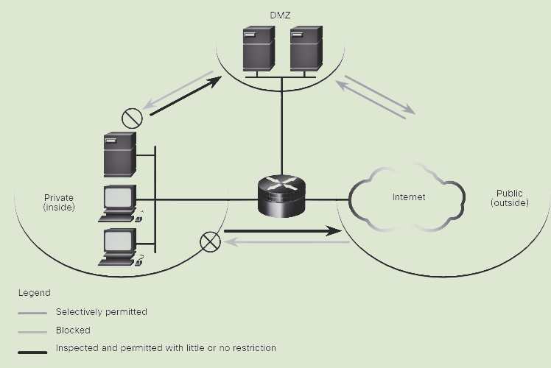

<https://www.cernvict.com/blog>